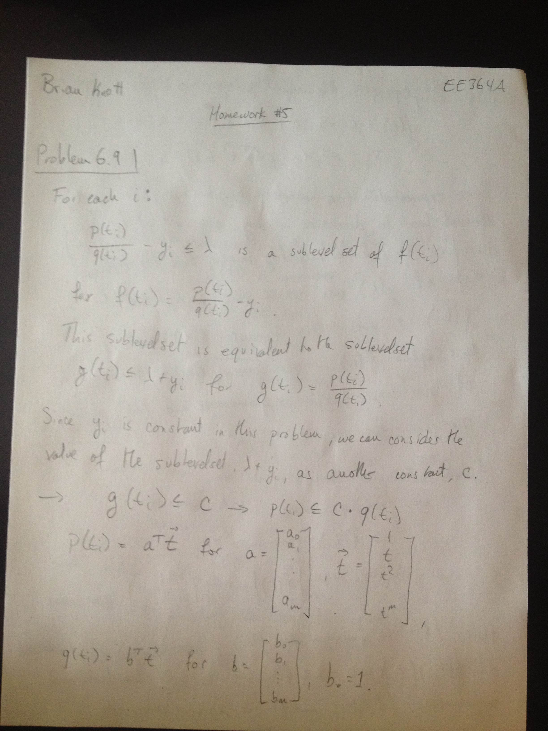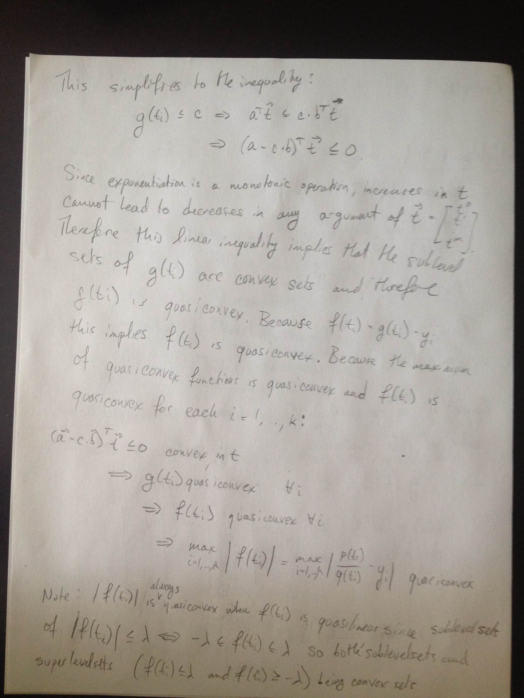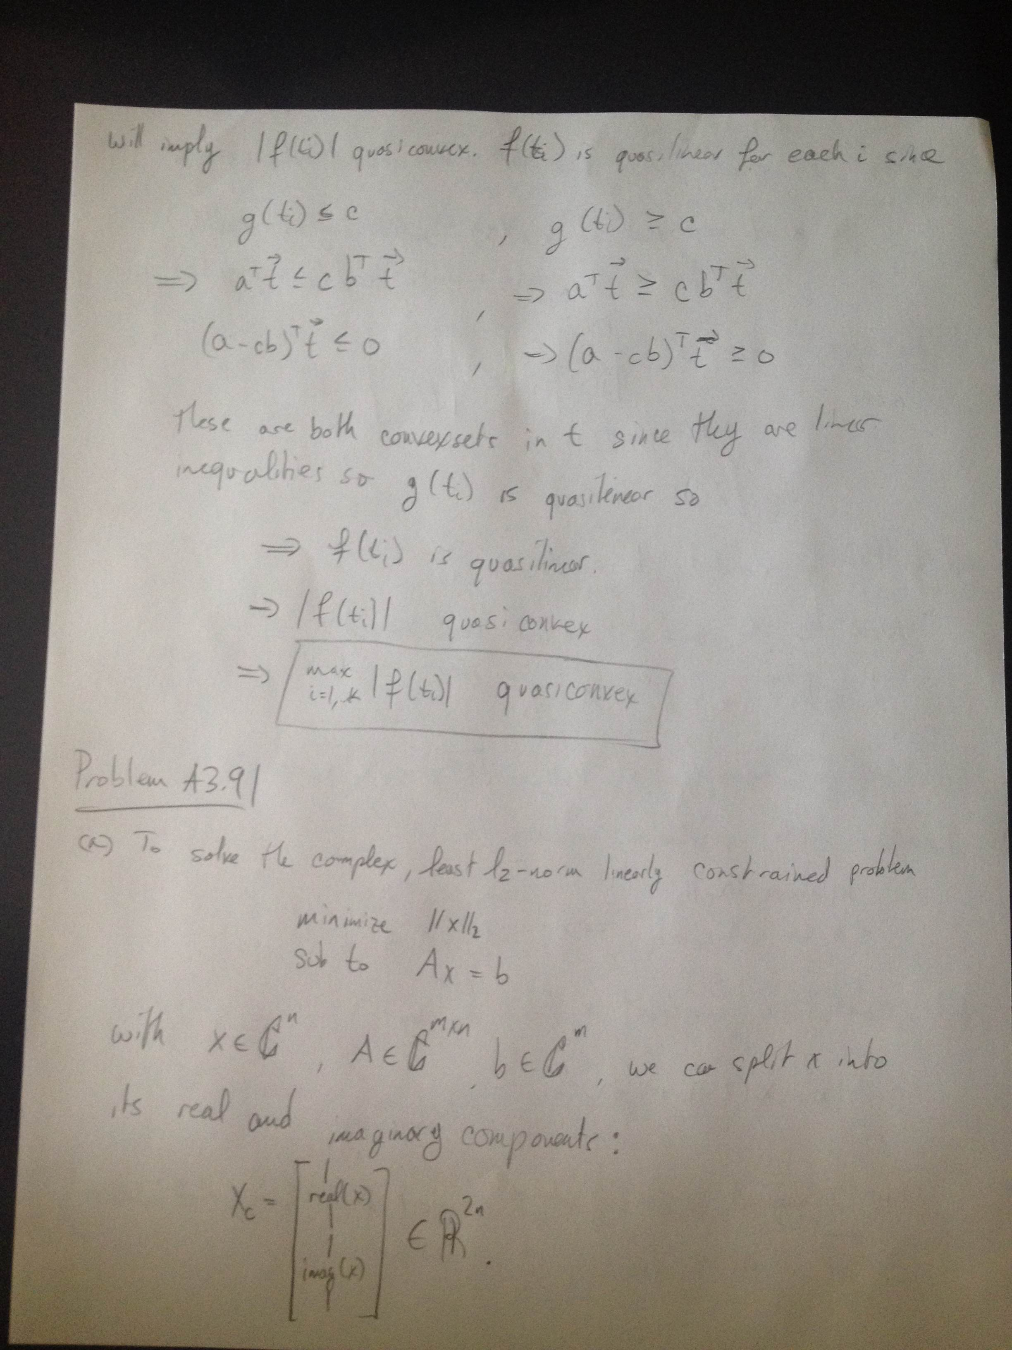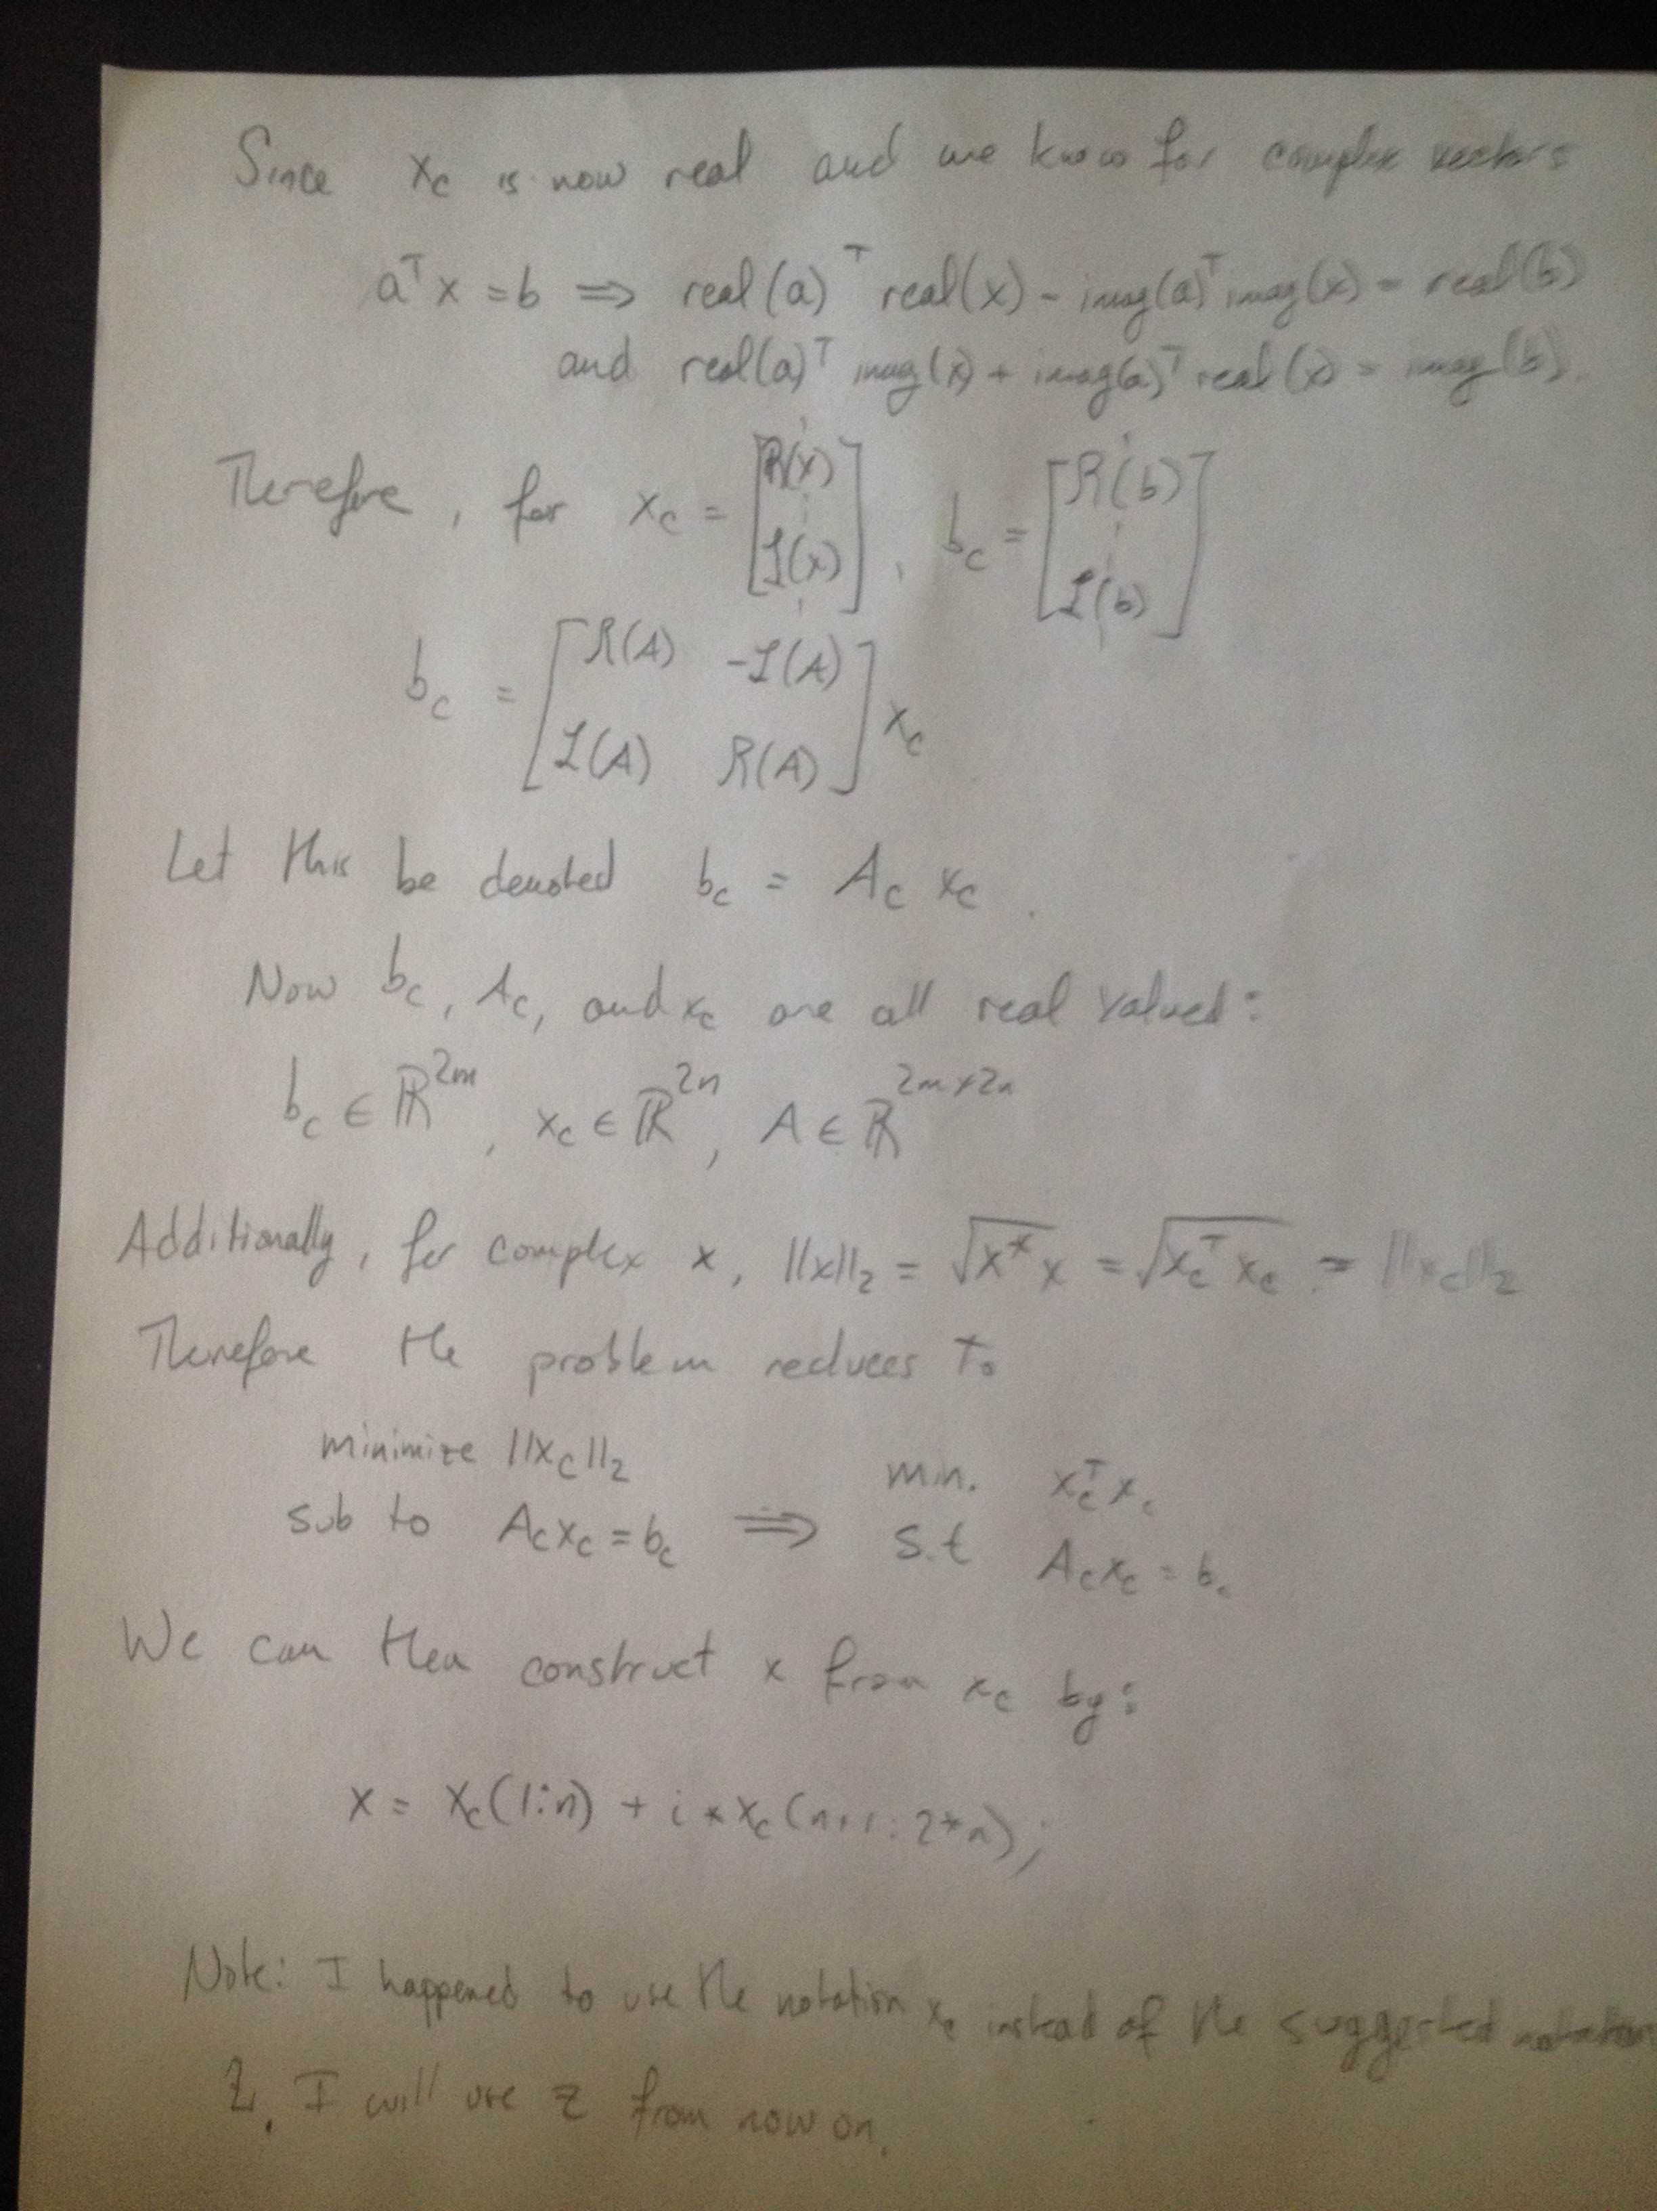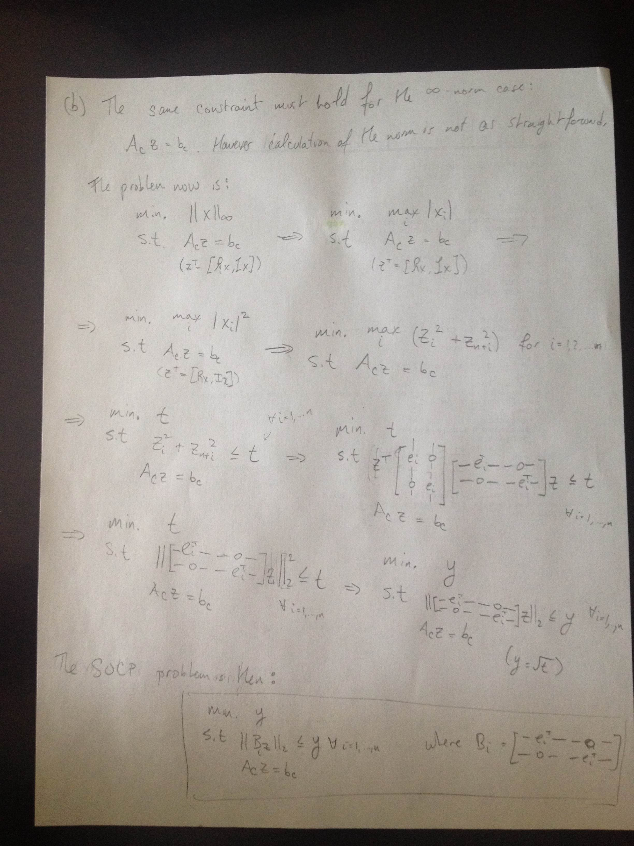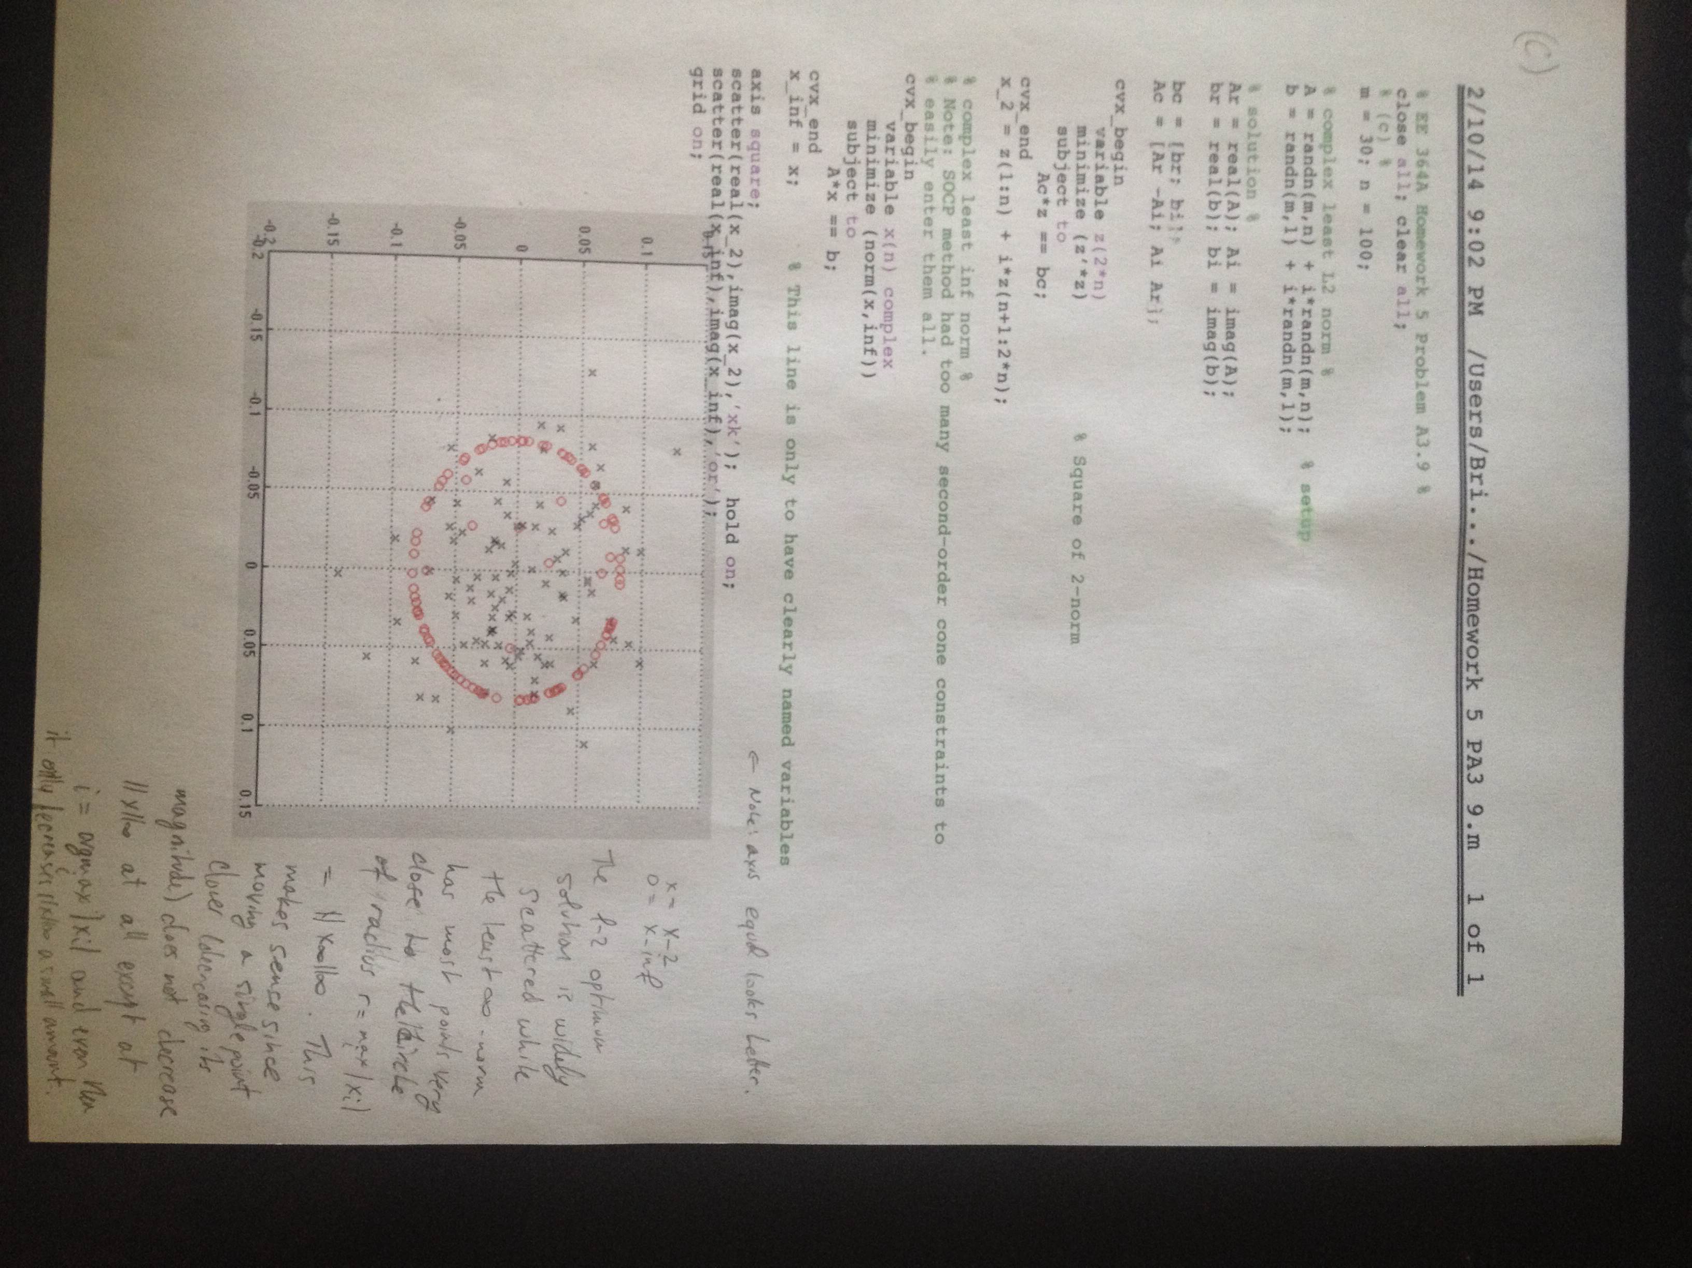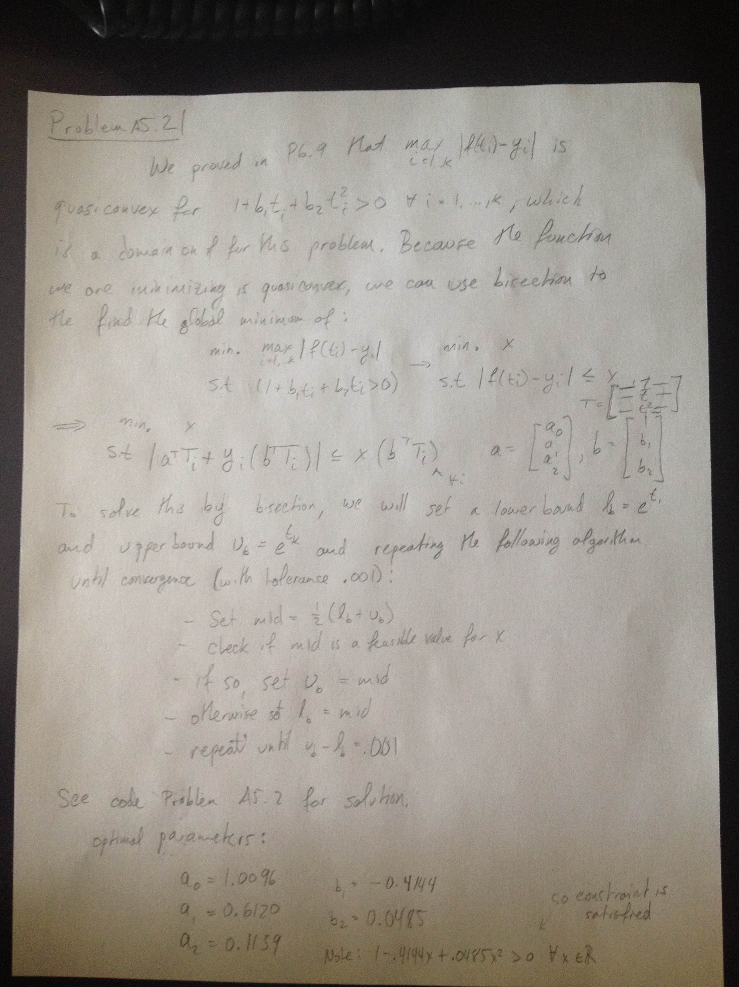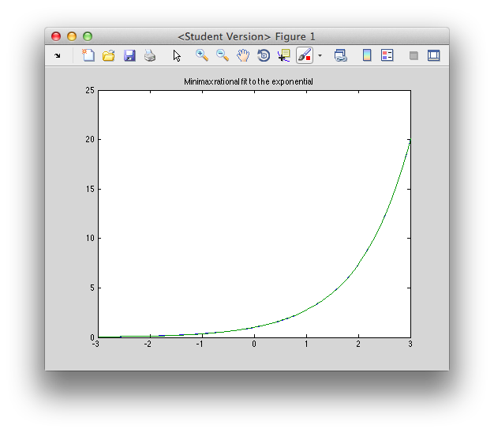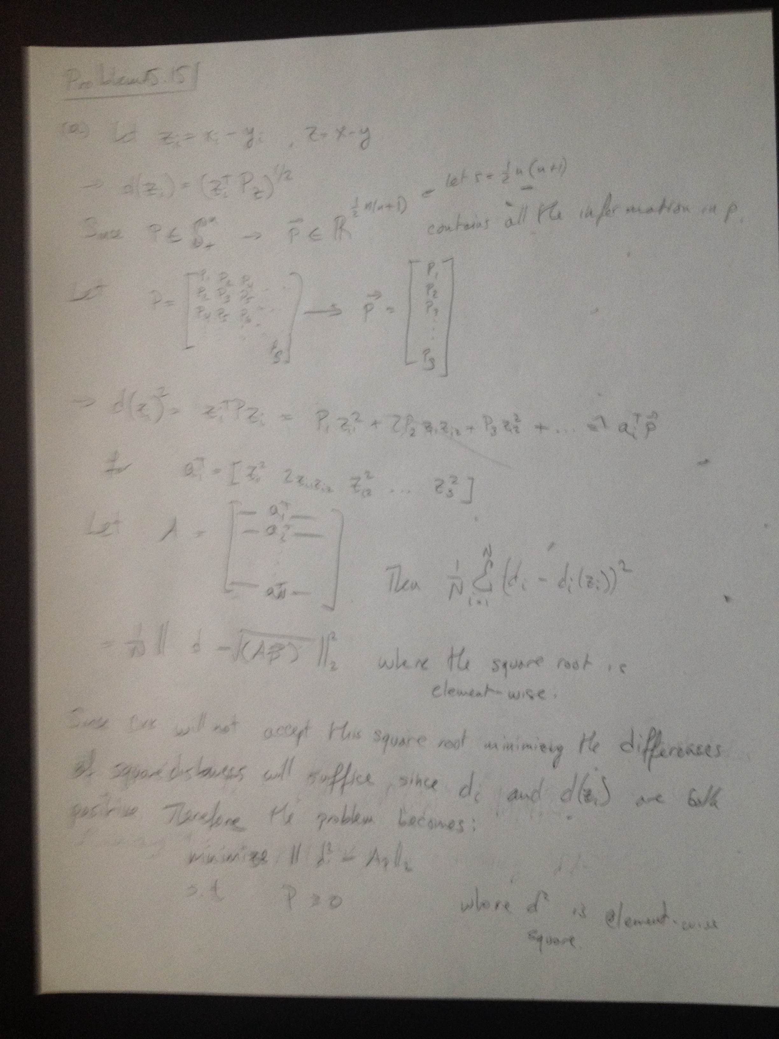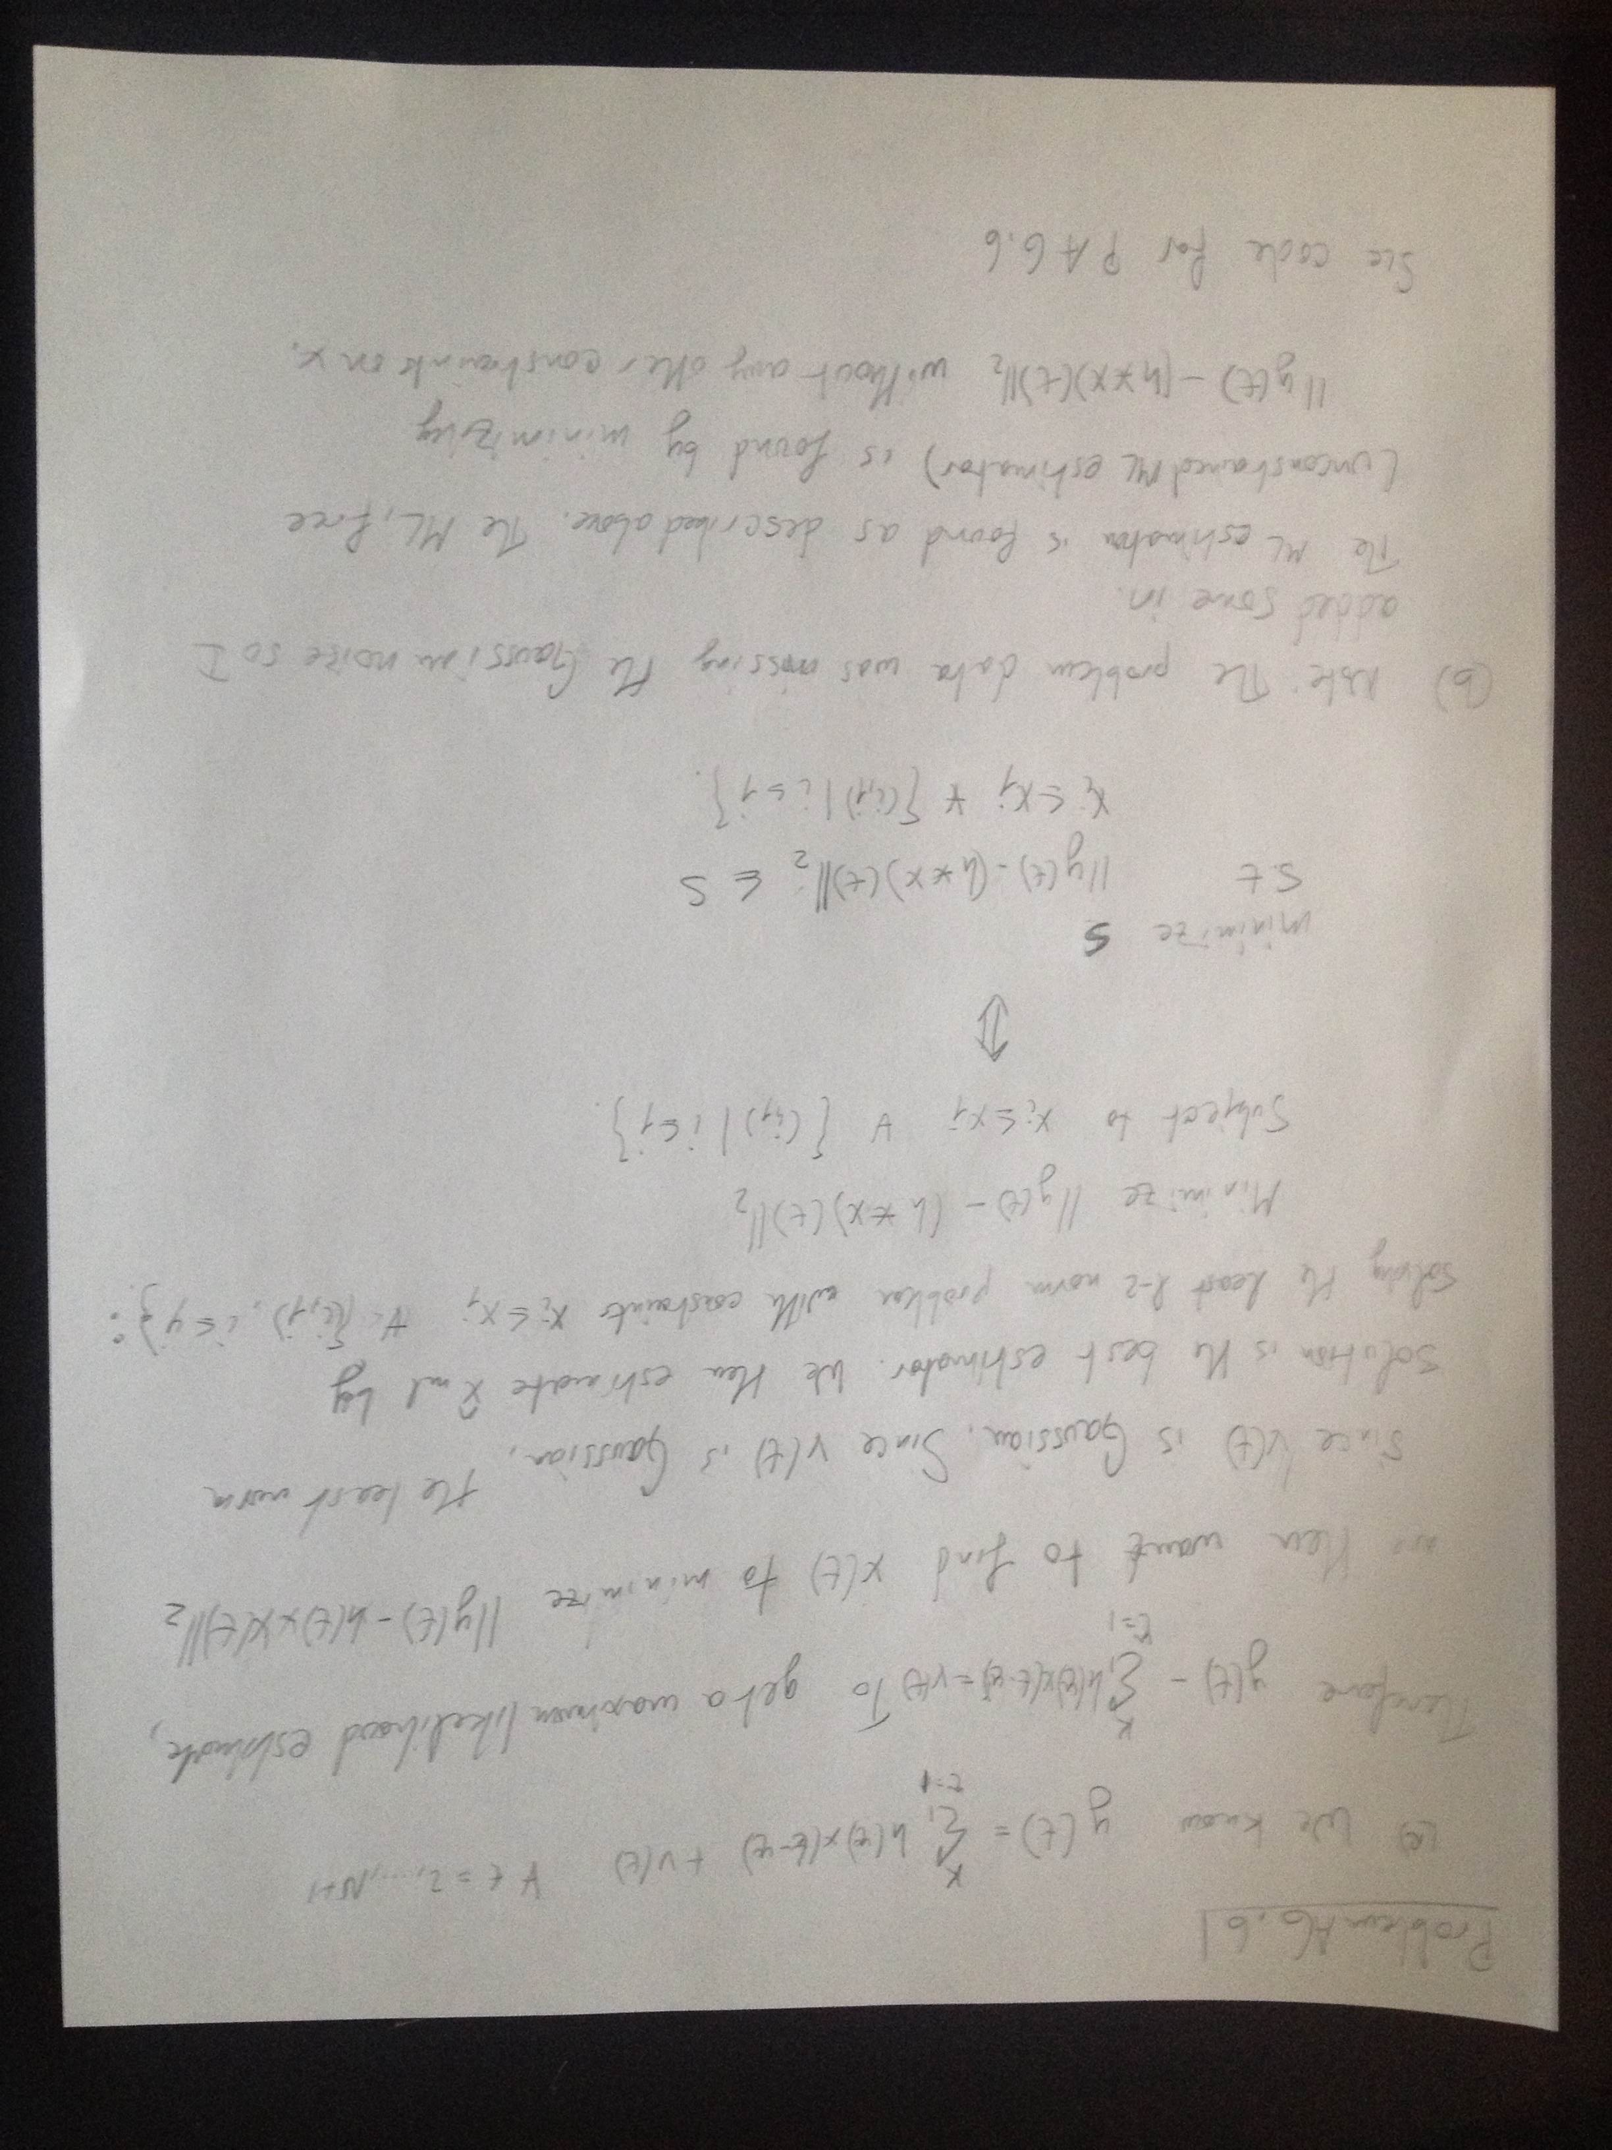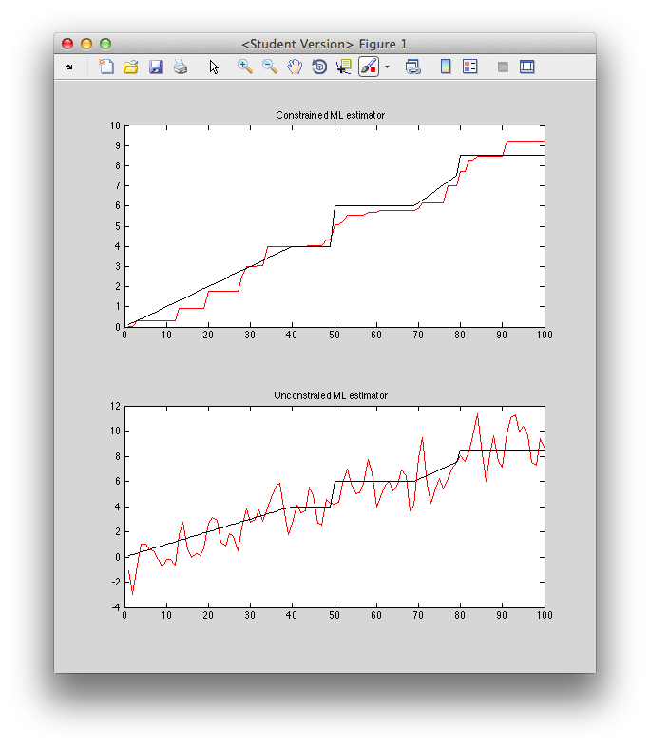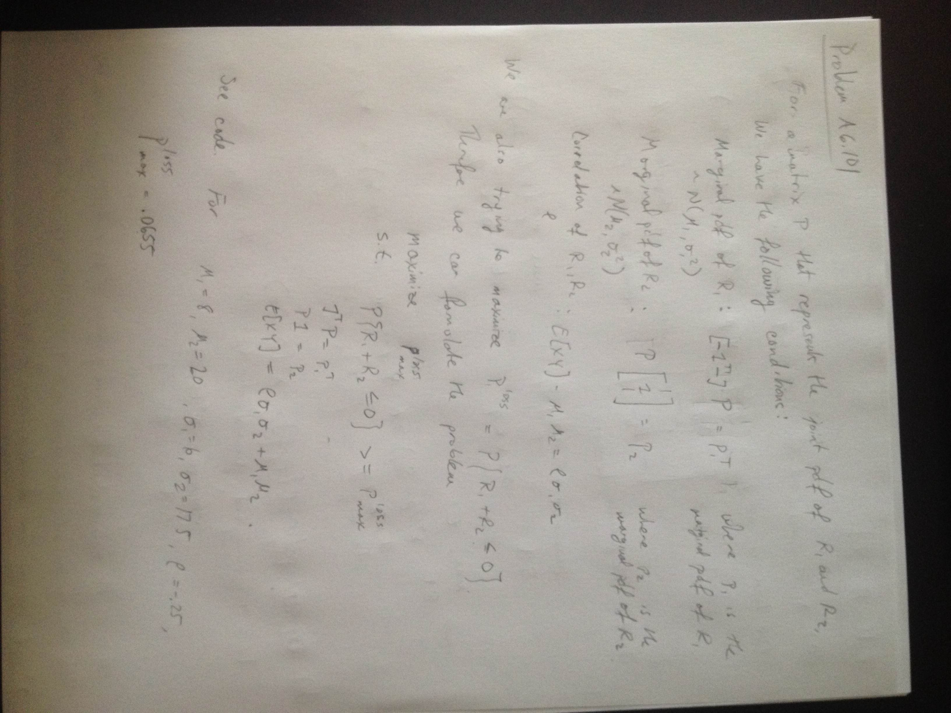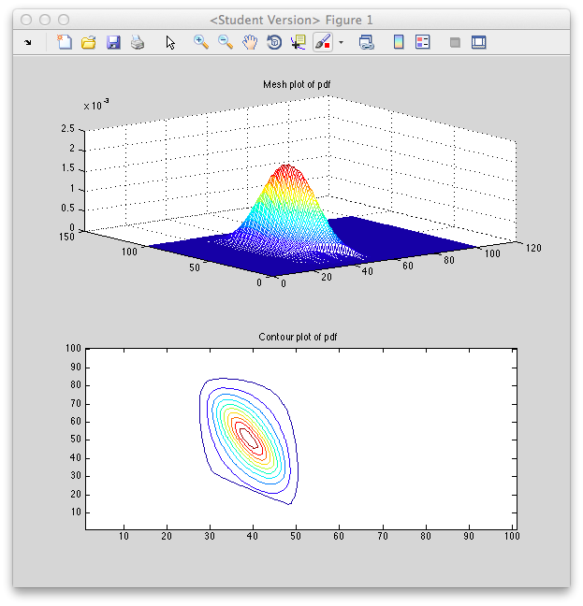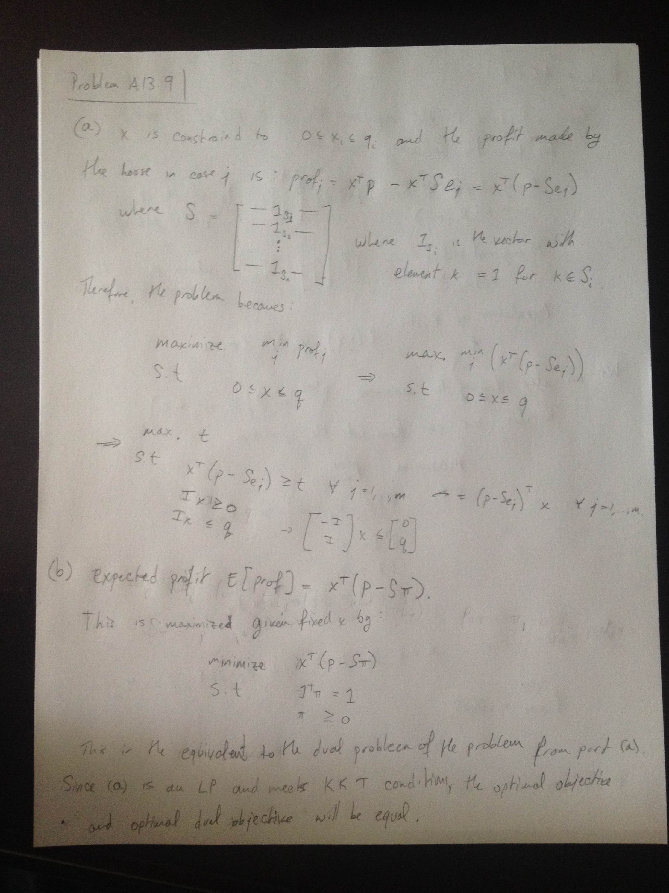

% EE 364A Homework 5 Problem A5.2 %

close all; clear all;

k= 201;

i = 1:k;

ti = -3 + 6*i/k;

yi = exp(ti);

x = [ones(1,k); ti; ti.^2];

ub = ti(end); lb = ti(1);

% Bisection Algorithm loop %

astar = []; bstar = []; pstar = 0;

while ub-lb >= .001,

p = .5*(ub+lb);

cvx_begin quiet

variable a(3)

variable b(2)

subject to

abs(x'*a - yi'.*(x'*[1;b])) <= p*x'*[1;b];

cvx_end

if strcmp(cvx_status,'Solved'),

ub = p;

astar = a;

bstar = b;

pstar = p;

else,

lb = p;

end

end

exp_approx = (x'*astar)./(x'*[1;bstar]);

exp_approx = exp_approx';

plot(ti,yi,ti,exp_approx);

% EE 364A Homework 5 Problem A5.15 %

close all; clear all;

quad_metric_data;

s = .5*n*(n+1); % dimension of P

Z = X - Y; A = [];

for i = 1:N,

z = Z(:,i);

row = [];

for j = 1:n,

for k = 1:j,

entry = z(j)*z(k);

if i~=j, entry = 2*entry; end

row = [row entry];

end

end

A = [A; row];

end

B = A.^.5;

cvx_begin

variable p(s)

variable q

minimize q

subject to

for i = 1:N,

norm(d'- B*p) <= q;

end

[p(1) p(2) p(4) p(7) p(11); p(2) p(3) p(5) p(8) p(12); ...

p(4) p(5) p(6) p(9) p(13); p(7) p(8) p(9) p(10) p(14);...

p(11) p(12) p(13) p(14) p(15)] == semidefinite(n);

cvx_end

P = [p(1) p(2) p(4) p(7) p(11); p(2) p(3) p(5) p(8) p(12); ...

p(4) p(5) p(6) p(9) p(13); p(7) p(8) p(9) p(10) p(14);...

p(11) p(12) p(13) p(14) p(15)];

Ztest = X_test-Y_test;

MSE = 0;

for i = 1:N_test,

z = Ztest(:,i);

dist = (d_test(i) - (z'*P*z)^.5);

MSE = MSE + dist;

end

MSE = MSE/N_test;

Test Mean Square Error = 5.02

% EE 364A Homework 5 Problem A6.6 %

close all; clear all;

ml_estim_incr_signal_data;

y = yhat + randn(103,1);

cvx_begin

variable xml(N)

variable t

minimize t

subject to

norm(y' - conv(xml,h)) <= t;

xml >= 0; % nonnegativity

for s = 1:N-1,

xml(s) <= xml(s+1); % nondecreasing monotically

end

cvx_end

subplot(211)

plot(1:100,xml,'r',1:100,xtrue,'k');

title('Constrained ML estimator');

% Free ML estimation %

cvx_begin

variable xmlf(N)

variable t

minimize t

subject to

norm(y'-conv(xmlf,h)) <= t;

cvx_end

subplot(212);

plot(1:100,xmlf,'r',1:100,xtrue,'k');

title('Unconstraied ML estimator');

% EE 364A Homework 5 Problem A6.10 %

close all; clear all;

r = -30:70;

n = length(r);

mu1 = 8; mu2 = 20; sigma1 = 6; sigma2 = 17.5;

rho = -.25;

% Setting up denominator %

d1 = 0; d2 = 0;

for j = 1:n,

d1 = d1 + exp(-(r(j)-mu1)^2/(2*sigma1^2));

d2 = d2 + exp(-(r(j)-mu2)^2/(2*sigma2^2));

end

% Setting up marginal distributions %

p1 = []; p2 = [];

for i = 1:n,

prob1 = exp(-(r(i)-mu1)^2/(2*sigma1^2))/d1;

prob2 = exp(-(r(i)-mu2)^2/(2*sigma2^2))/d2;

p1 = [p1; prob1];

p2 = [p2; prob2];

end

X = r'*ones(1,n);

Y = ones(n,1)*r;

Z = zeros(n,n);

Z(X+Y <= 0) = 1;

XY = X.*Y;

cvx_begin

variable P(n,n) nonnegative

variable t

maximize t

subject to

sum(P.*Z) >= t; % Maximize objective

P*ones(n,1) == p2; % R2 marginal

ones(1,n)*P == p1'; % R1 marginal

XY(:)'*P(:) == rho*sigma1*sigma2 + mu1*mu2;

% Correlation condition.

cvx_end

Ploss = sum(sum(P.*Z))/sum(sum(P));

subplot(211); mesh(P); title('Mesh plot of pdf');

subplot(212); contour(P); title('Contour plot of pdf');

x_opt = [5 ; 5 ; 5 ; 5 ; 10]

max worst case profit = 3.5

Imputed probability pi for x_opt:

Pi = [.2007 ; .1993 ; .2004 ; .1999 ; .1997]

% EE 364A Homework 5 Problem A13.9 %

close all; clear all;

p = [.5 .6 .6 .6 .2]';

q = [10 5 5 20 10]';

S = [1 1 0 0 0; 0 0 0 1 0; 1 0 0 1 1; 0 1 0 0 1; 0 0 1 0 0];

cvx_begin

variable x(5) %integer

variable t

maximize t

subject to

x >= 0;

x <= q;

for j = 1:5,

x'*(p- S(:,j)) >= t;

end

cvx_end

% caculating worst case house profit for x = q %

wchp = 1e10; % Initializing house profit to a high value

for j = 1:5,

profit_j = q'*(p-S(:,j));

wchp = min(wchp, profit_j);

end

% Calculating imputed probabilities %

cvx_begin

variable ppi(5)

maximize (x'*(p-S*ppi));

subject to

eye(5)*ppi >=0;

ones(1,5)*ppi == 1;

cvx_end